
East West University

Lab Report
Semester: Summer-2025
Course Title: Electronic Circuits Course Code: CSE251
Section: 04

Expt No: 05
Expt Name: Adder Circuit using 741 Op Amp
Group No: 06
Group Members:
Student Name | Student Id
Md. Hasib Ali | 2023-3-60-186
Arijit Kumar Anoy | 2023-3-60-055
Md. Shakib Al Hasan | 2024-1-60-200
Fahim Shahriar | 2023-2-60-094
Morshedul Islam | 2023-2-60-125

Submitted by-
Name: Md. Shakib Al Hasan
Id: 2024-1-60-200

Submitted to-
Dr. Sarwar Jahan
Associate Professor
Department of Computer Science & Engineering
East West University

Date of Performance: August 04, 2025
Date of Submission: August 11, 2025
Title: Adder Circuit using 741 Op Amp.

Objectives
1. To familiarize with the 741 Op Amp Integrated Circuit (IC).
2. To design and construct an adder using 741 Op Amp.

Theory (Summary)
Operational Amplifier (Op Amp) is a differential amplifier and can perform mathematical operations such as addition, subtraction, etc. This is an integrated circuit (IC).
The block diagram of the 741 Op Amp is shown in Figure-1. It has 8 pins. To identify the pins of the 741 Op Amp in the laboratory, place the Op-Amp on the trainer board in such a way that the notch is in your left side. Then the pin number should be identified as shown in Figure-1.
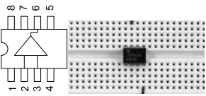

Figure-1: Block diagram of the 741 Op-Amp

The names of different pins are as follows:
1: Offset null (usually not used)
2: Inverting input terminal
3: Non-inverting input terminal
4: Negative DC power supply (usually 5-15V negative)
5: Offset null (usually not used)
6: Output terminal
7: Positive DC power supply (usually 5-15V positive)
8: Not connected (NC)
The Op Amp acts as an adder when the non-inverting input terminal is grounded and two or more signals are fed to the inverting input via resistors of appropriate values. The output becomes negative of the sum of the input signals.
A non-inverting amplifier produces the amplified output equal to the input multiplied by the closed loop gain, which is determined by the appropriate resistances.
Equipment and Component
1. Digital trainer board
2. DC power supply
3. Signal generator
4. Oscilloscope
5. Digital multimeter
6. 741 Op Amp (1 pc)
7. Resistor (as required from pre-lab design)
8. Breadboard
9. Connecting wires

Circuit Diagram
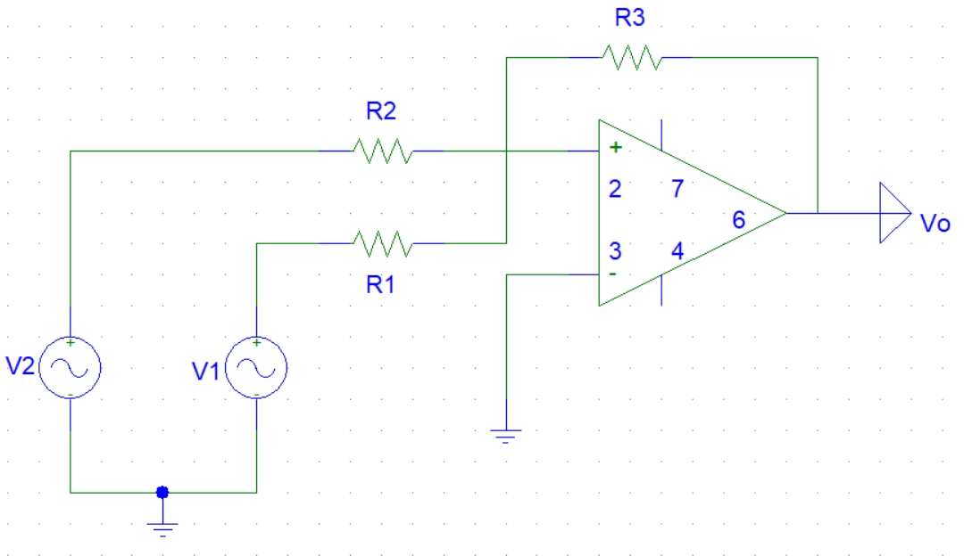

Figure-2: an adder circuits using 741 Op Amp.

Pre-Lab
1. DESIGN OF ADDER CIRCUIT: Design the adder circuit shown in Figure-2 (determine the values of the resistors) so that it implements the function $V=-{(V}_{1}+{2V}_{2})$. The available set of resistances that you can use is 1002, 1ΚΩ, 2.2ΚΩ, 3.3ΚΩ, 5.6ΚΩ, and 10ΚΩ. For design safety, take Rf as high as possible. In your design, if exact value of resistance is not available, choose the nearest one.
Answer
As we are using only 1 Op Amp, we can design the circuit as follow:
We know, For adder circuit, $V_{o}=- (\frac{R_{F}V_{1}}{R_{1}}+\frac{R_{F}V_{2}}{R_{2}} +.……....+\frac{R_{F}V_{N}}{R_{N}})$……………. (i)
Comparing equation (i),
$\frac{R_{F}}{R_{1}}=1$
$\frac{R_{F}}{R_{2}}=2$
⸫ $R_{2}=0.5R_{F}$
Since we are required for taking $R_{F }$ as high. $R_{F }=10KΩ, R_{F }=5 KΩ.$
Since we don’t have 5KΩ resistor, but we have 5.6KΩ.
$$⸫ R_{2}≈5.6KΩ.$$

Post-Lab
1. From the measurement in step-3, verify your design.
Answer
Here,$V_{1}=5V; V_{2}=2V;$
Output voltage, $V_{o}=-\left(V_{1}+2 V_{2}\right)V=- (5+4) V=- 9V$
$V_{o}=- (V_{1}+2 V_{2}) V=-(5+4) V=- 9V$
And from the measurement Output voltage, $V=-12.99V$

2. Does the amplitude measured in step-4 verify your design? Explain.
Answer
Amplitude measured in step 4 is 4.80V as we used 5V from AC power supply and the output taken from DC mode. So, the amplitude is almost the same here.
3. Simulate the circuit shown in Figure-2 in Pspice. Use $V_{1}$ a 5V peak to peak, 1KHZ, $0^{0}$ phase sine wave and $V_{2}$ a 5V peak to peak, 1KHZ, ${90}^{0}$ phase sine wave. Perform simulation for 4 cycles (transient analysis for 4 ms) and attach the printed output with your report.
Answer
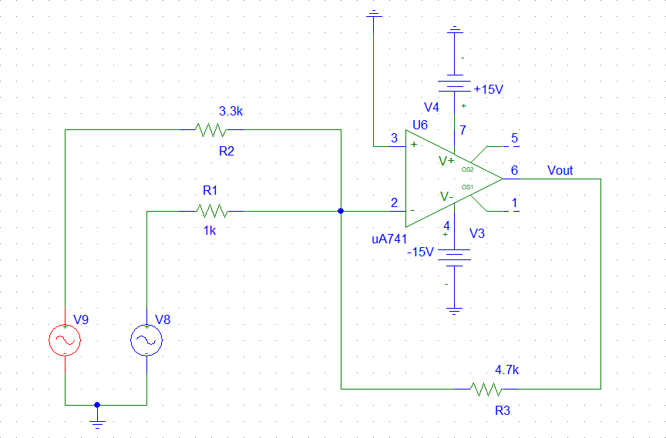

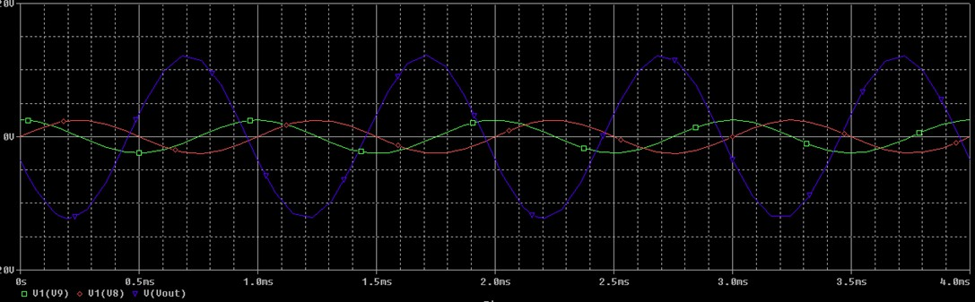

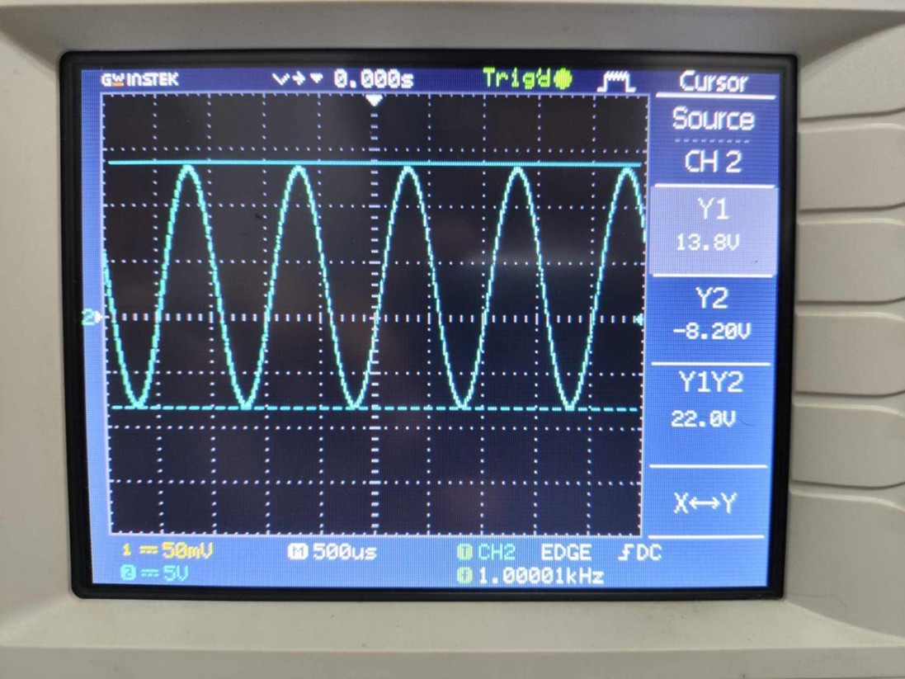

4. Write the expressions of $V_{1}$ and $V_{2}$ of Question-3 in phasor domain, add them, and write the result in time domain as a sine function. Compare it with the Pspice output in terms of amplitude, phase angle, and time period.
Answer

In Phasor domain,
Here, $V_{1 }=2.5∠0^{0}V , V_{2 }= 2.5∠{90}^{0} V$
$V_{1 } + V_{2 } = 2.5∠0^{0}V +2.5∠{90}^{0} V= 3.536 ∠{45}^{0}V$
So, phase angle, $φ={45}^{0}$

Now,
Amplitude of magnitude, $V_{m}=\sqrt{\left\{\left(2.5\right)2 + \left(2.5\right)2\right\}}=3.536 V$
Angle, $θ=\tan^{-1}(\frac{2.5}{2.5})={45}^{0}$

In time domain we know,
$$V_{t}=V_{m}cos(ωt+φ)$$
$$Or, { V}_{t}=V_{m} cos(2πft+φ)$$
$$V=3.536cos(2πft+{45}^{0}) [ f=1kHz=1000Hz ]$$
$$=3.536cos(2000πt+{45}^{0})$$
$$=3.536 sin(2000πt+{45}^{0}+{90}^{0})$$
$$=-3.536sin(2000πt+{135}^{0})$$

We know,
Time period, $T=\frac{1}{f}=\frac{1}{1000}=10-3 s=1ms$

From PSpice simulation,
We find amplitude = 4.80V, Phase angle = ${90}^{0}$ And time period = 1ms

Comparison between PSpice and theoretical calculation:
 | From PSpice | From calculation
Amplitude | 4.8V | 4.8V
Phase angle | $${90}^{0}$$ | $${45}^{0}$$
Time period | 1ms | 1ms
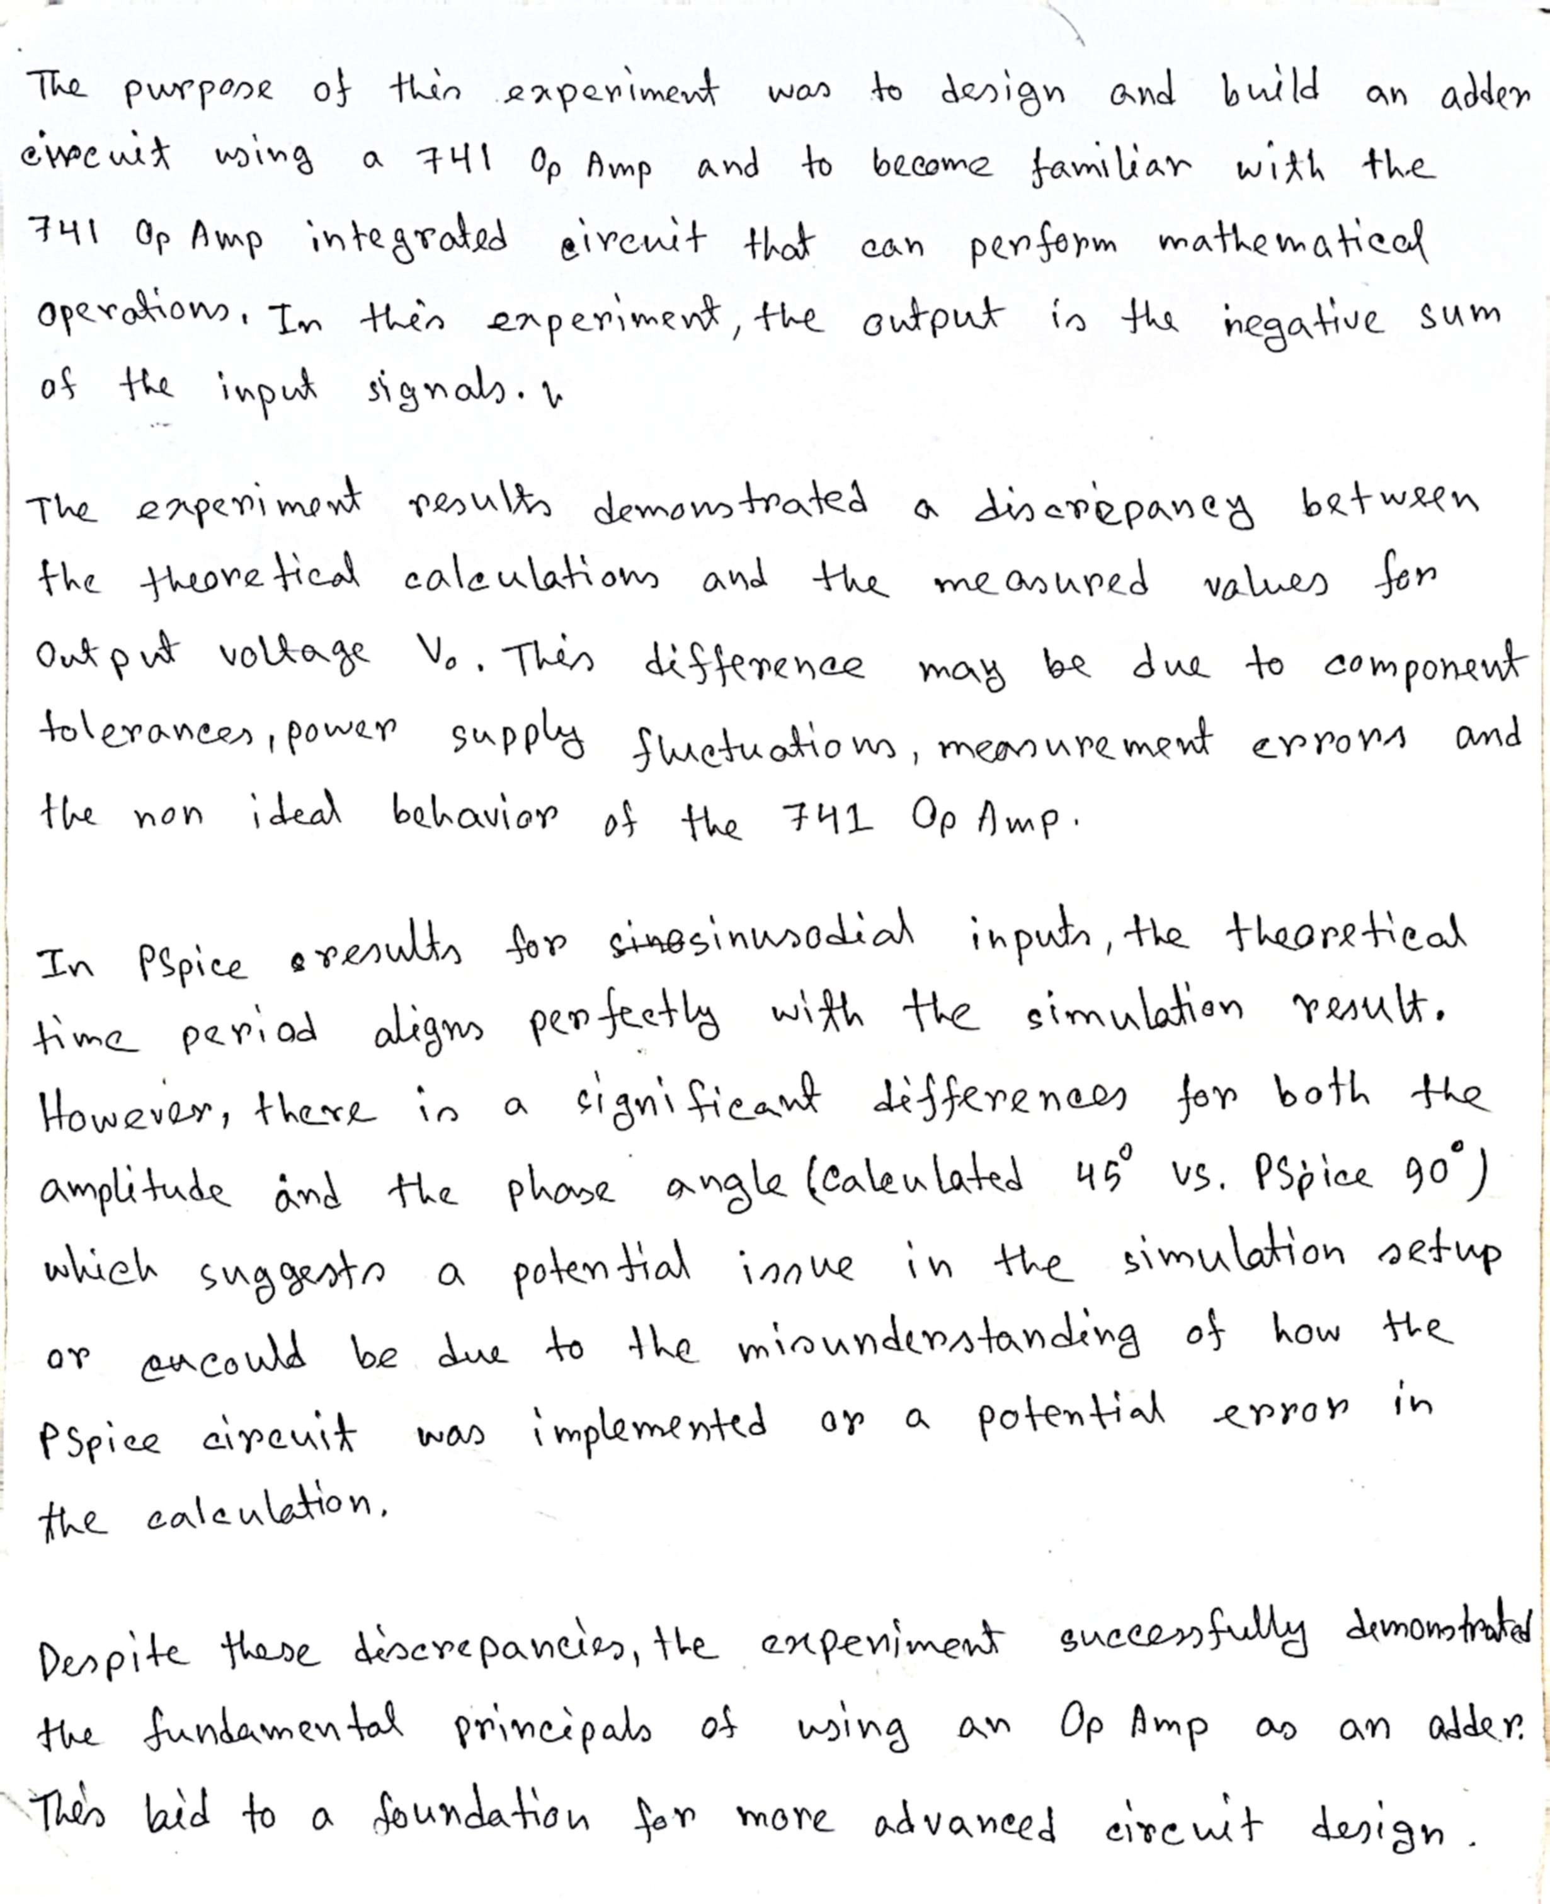
Discussion

